**Updates:**

1. Created my own sample database to test the functions.
2. Inside a subject screen:

* MainScreen(Subjects Screen)

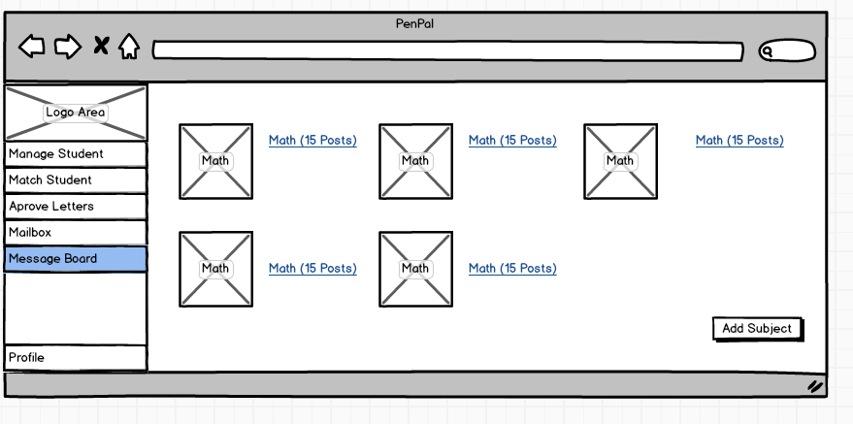

1. Onload of this screen it should retrieve Subjects, post number, and subject pictures from Database (Message table).
2. OnClick the AddSubject button should invoke a method to post a new subject and a new post to the database to both Subject and posts tables.

**Updates and what’s been done:**

* 1. OnLoad the page gets connected to the sample database and pulls the number of posts from the database and display it as a link.
  2. OnClick for the “Add Subject” button redirects to another php page (AddSubject.php).
* Inside a Subject

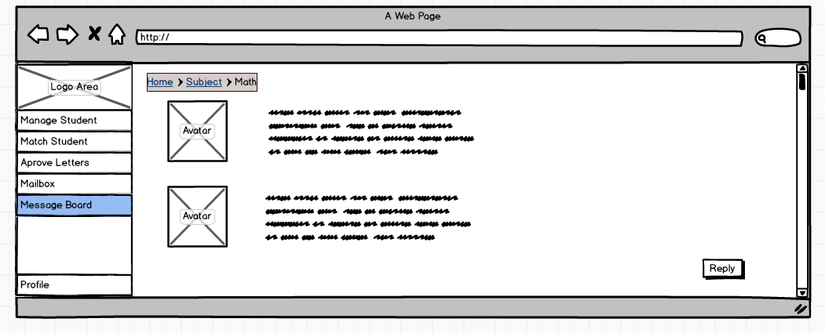

1. Onload of this screen it should also get the posts and the posts contents from the database (Subject table I guess). And the Avatar from the users table.
2. Onclick Reply button should redirect the user to reply screen.
3. OnClick Subject link it should redirect the user to the Subjects screen.

**Updates and what’s been done:**

1. Onloads the posts got pulled from the database. But the avatar is hard coded, I added the avatar inside the html body.
2. I added a link (more) by the end of each post to load more content if there is more. When clicked it redirect the user to another page with the whole post pulled from the database using
3. OnClick reply it directs the user to another page

* Reply

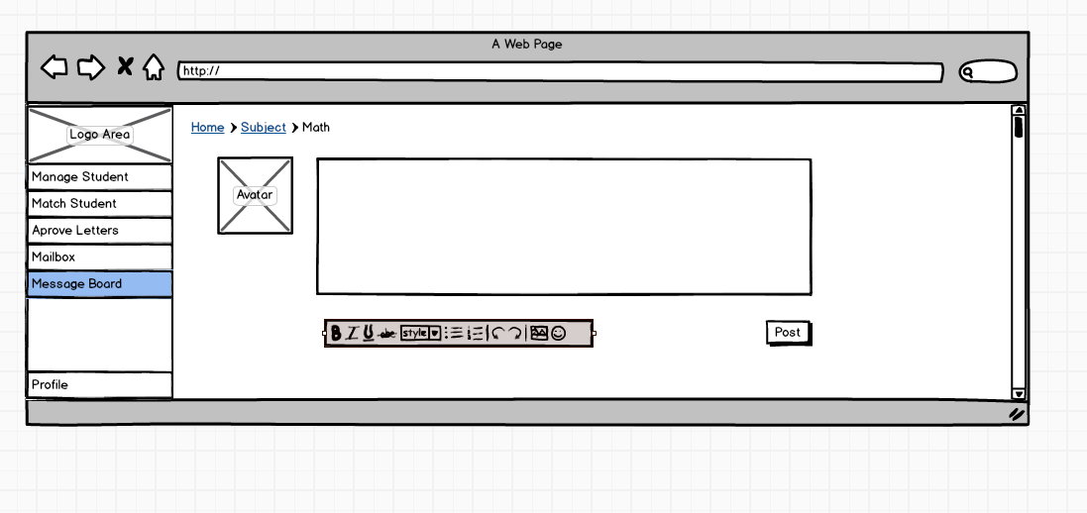

1. OnClick the Post button it will invoke a method to post the content of the text area to the message table and linking the user to that post.
2. OnClick Subject link it should redirect the user to the Subjects screen.

**Updates and what’s been done:**

1. Onclick subject link you will be directed back to the subject page.
2. I wasn’t don’t with the post method but it’s almost the same as addsubject method (which connecting to the database and posting information in a certain fields)

* AddSubject

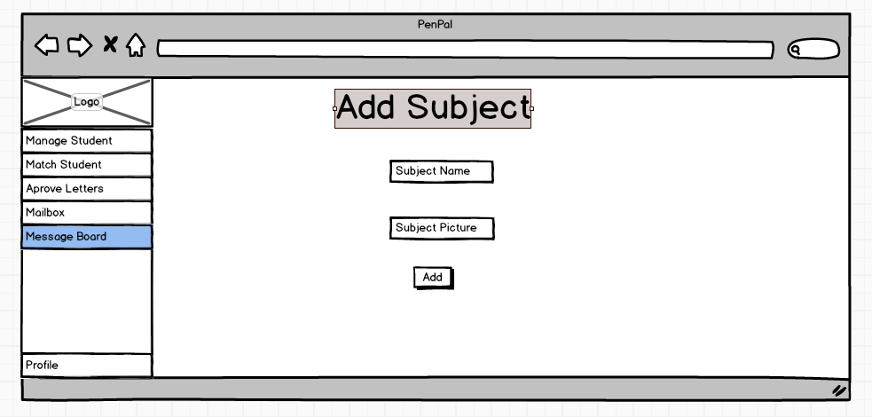

1. Onclick the add button, it will add the subject and the image to the database (Subject table).

**Updates and what’s been done:**

1. OnClick the add button it adds subject to the database but not image for that subject.
2. I changed the layout a little bit aliened everything to the left and used a bootstrap for the image browse button to look more attractive